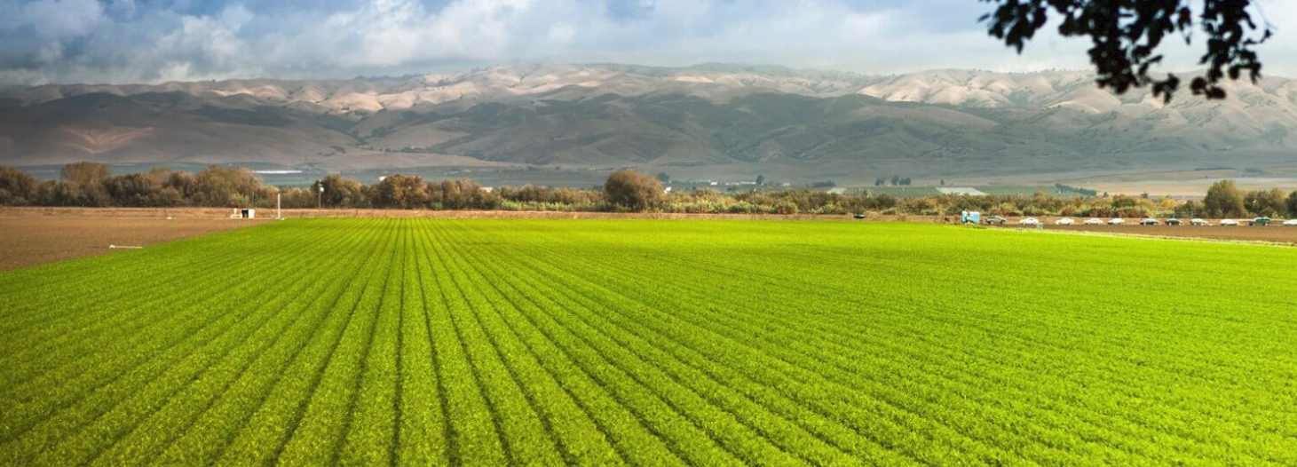

http://www.conservation.ca.gov/dlrp

Department of Conservation
High School Lesson Sequence: Protecting our Natural Resources

California Next Generation Science Standards:

HS-LS2-7. Design, evaluate, and refine a solution for reducing the impacts of human activities on the environment and biodiversity.* [Clarification Statement: Examples of human activities can include urbanization, building dams, and dissemination of invasive species.]

California Environmental Principles and Concepts:

Principle I—People Depend on Natural Systems. The continuation and health of individual human lives and of human communities and societies depend on the health of the natural systems that provide essential goods and ecosystem services.
Principle II—People Influence Natural Systems. The long-term functioning and health of terrestrial, freshwater, coastal and marine ecosystems are influenced by their relationships with human society.
Principle III—Natural Systems Change in Ways that People Benefit from and Can Influence. Natural systems proceed through cycles that humans depend upon, benefit from and can alter.
Principle IV—There are no Permanent or Impermeable Boundaries that Prevent Matter from Flowing Between Systems. The exchange of matter between natural systems and human societies affects the long-term functioning of both.
Principle V—Decisions Affecting Resources and Natural Systems are Complex and Involve Many Factors. Decisions affecting resources and natural systems are based on a wide range of considerations and decision-making processes.

Anchoring Phenomenon for lesson sequence: Human population growth changes landscapes.

Lesson 1

Learning Objective: Students will investigate how changes in California land use have impacted agriculture and the environment.

Investigative Phenomena: The amount of prime farmland is changing.

Guiding Question: How is the expansion of urban development impacting land use?

Lesson Implementation Timeframe: 4-5 (50-60 minute) class periods

Classroom Resources and Materials:
- Protecting our Natural Resources Lesson 1 PowerPoint Beta
- Student Handout: HS L1 H1 Important Farmland Categories
- Student Handout: HS L1 H2 The Quest for Everlasting Agriculture
- Student Handout: HS L1 H3 Statewide Farmland Conversion Table
- Student Handout: HS L1 H4 SALC Program Project Summaries

Procedures:
Engage

- Display slide 1. Welcome students and introduce the lesson sequence by identifying the guiding question, “How is the expansion of urban development impacting land use?”

- Display slide 2. Ask students to make observations of estimated changes in California land use from 2001 – 2100 using the simulation created by the United States Geological Survey (USGS). Tell students to write down their observations in a science notebook. Ask students to share their observations with a partner. After allowing each student adequate time to share with his/her partner, request a few volunteers to share their answers with the class. Students may notice that developed space and perennial agriculture is increasing and annual agriculture, grasslands, forests, shrublands are decreasing. It is more difficult to determine if water, snow/ice, wetlands, barren, and transportation is changing, but accept all answers. Students might notice a shift in farming practices from annual to perennial agriculture. Let students know that they will explore the difference between perennial and annual agriculture later in the lesson. Allow students to ask additional questions about the simulation. Do not attempt to answer questions. It is important to take note of prior knowledge to help make adjustments in the learning sequence to answer many of the questions later in the lessons.

- Display slide 3. Ask students, “What factors do you think were included in the model to create the simulation?” Human population growth is the main factor, but additional factors may include projected changes in climate, economy, migration and immigration patterns.

Share with students that they will examine land use data from 1984–2008. Students will conduct an investigation of the type of land use changes that occurred in the Brentwood/Antioch area.

Explore #1

- Display slide 4. Ask students to make 5 – 10 observations from the animation of the Brentwood/Antioch area between the years of 1984 – 2008 (ftp://ftp.consrv.ca.gov/pub/dlrp/FMMP/animation/GIF_files/ts_brentwood_8408.gif) and write their observations in their science notebook. Tell students to generate two or more questions from their observations.

You can show other animated maps for the following locations, which might be closer to your school or county. (ftp://ftp.consrv.ca.gov/pub/dlrp/FMMP/animation/GIF_files/):
Image 1
- Brentwood/Antioch
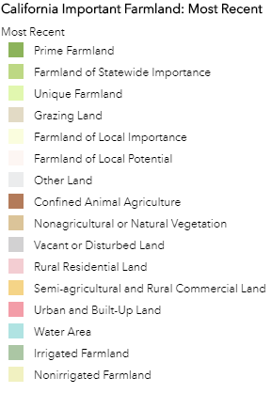
- Coachella
- Corona
- Elk Grove
- Fresno
- Merced
- Modesto
- Sacramento/Natomas Basin
- Oxnard
- Roseville
- Sonoma Valley
- Tracy

*These are gif files.

- Display slide 5. Ask students to interpret the animation/picture by defining the colors labeled in Image 1. Provide students with HS L1 H1 Important Farmland Categories to assist them in understanding each category.

- Display slide 6. Ask students to share their list and questions with their partner. Tell students to generate a longer list of observations and identify at least two additional questions that they would like to investigate further. Ask a sample of students to share their investigative question.

- Display slide 7. Ask students to continue to think about how agriculture is changing over time, comparing future predictions (engage activity) and exploring the past data (explore #1 activity). Tell students to make a claim using evidence from the simulations about how agriculture has changed over time. The teacher might offer to students if they need additional support in writing a claim the following sentence frame, “Based on my observations from the simulation, my claim is that agriculture has _____________ over time.” Survey the class by asking how many students claimed that agriculture has increased over time? Decreased? Indicate to students that they need more evidence and reasoning to support their claim.

Explain #1

- Display slide 8. Explain to students that farmers grow perennial and annual plants. Define the two types of plants using the following definitions:

- Perennial plants survive and produce multiple-years. Examples of perennial plants grown for agriculture include kale, garlic, asparagus, and artichokes.
- Annual plants have a one-year growing season. Examples of annual plants currently grown include corn, wheat, rice, lettuce and peas.

- Display slide 9. Pass out the student handout (HS LS1 H2) and ask students to access “The Quest for Everlasting Agriculture” article (https://www.pbs.org/wgbh/nova/article/perennial-agriculture/). Provide students with time to read and complete the handout. Review student answers by asking students to share their findings with another partner. Invite individual students to share their answers with the whole class. Using the information students synthesized from the reading and recorded on their handout, ask students to revisit their claim. How might the type of crops grown change in the future? Based on the article, perennial plants might be a strategy to meet the demands of a growing population, climate change, and biodiversity loss.
  - Also have students read two more documents for further clarity:
    - From FAO (http://www.fao.org/fileadmin/templates/agphome/documents/scpi/PerennialPolicyBrief.pdf)
    - From the Land Institute (Perennial Crops: New Hardware for Agriculture’

- Display slide 10. Remind students that the simulation at the beginning of the lesson predicted future land use. Ask students, “What is one component of the model (simulation) at the beginning of the lesson that we investigated?” One of the components in the model was agricultural land use. Ask students to share how the article suggests that perennial plants have the potential to grow more food during the year and they may be a healthier balance in our ecosystem. This is an important factor in the simulation model. Remind students that fruits are grown on perennial trees and shrubs. Examples of plants that might meet the demands of a growing population in the future include perennial grains, legumes and oilseed.

Explore #2

- Display slide 11. Display the Department of Conservation Infographic (https://www.conservation.ca.gov/dlrp/Pages/Outreach%20Materials.aspx) on how the Division of Land Resource Protection is helping to preserve land for farmers. Ask students, “What evidence is provided by the infographic that explains the importance of farmland in California?” 43% of our land is used for agriculture and it supplies 67% of fruit and 34% of vegetables in the U.S.

- Display slide 12. Tell students to locate the nearest prime farmland to their school by using the California Important Farmland Finder (https://maps.conservation.ca.gov/agriculture/).

To access the map, go to the Department of Conservation website: https://maps.conservation.ca.gov/agriculture/. Open up the “California Important Farmland Finder” map. Read about and accept the data disclaimer to open the farmland finder map.

To identify the nearest farmland, go to the left-hand side of the map and find the search box and type in your school address or zip code in the “Find address or place” space. Zoom in or out by using the + or – buttons on the left-hand side of the map to orient yourself to the map. Using the key, determine where the closest prime farmland (dark green) exists near your school.

Ask students, “Do you believe that land use has changed over time in our county?” and “What data might you need to support your prediction?”

- Display slide 13. Ask students, “How has land use changed over time in our county?” Share with students that they will have the opportunity to learn more about how land use has changed in their county by analyzing how much farmland has been converted into urban/built-up land from 1984 to 2016.

- Display slide 14. Instruct students to go to the following webpage: https://www.conservation.ca.gov/dlrp/fmmp/Pages/county_info.aspx and select the county where their school is located. Select the “Historic Land Use Conversion” table from 1984 – Present. The report will download automatically as an excel document. Pre-printed copies of the excel sheet can be prepared for students in advance (HS LS1 H3 Statewide Farmland Conversion Table). Ask students to analyze the data.

- Display slide 15. Using data from your county, ask students to make a claim about the conversion of local farmland. Offer the following sentence frame if students need help writing a claim statement, “My claim is that land use in _____ county has _increased/decreased_ between 1984 – 2016, there was a change of _______ acreage of important farmland that was converted.”

Share with students that they will be analyzing statewide farmland conversion data to support their claim.

- Display slide 16. Instruct students to go back to the previous webpage: https://www.conservation.ca.gov/dlrp/fmmp/Pages/county_info.aspx and select the “Statewide Table” for the years between 2010 – 2012. This report will download automatically as an excel document. Pre-printed copies of the excel sheet can be prepared for students in advance (not provided as a handout). Ask students to analyze the data and revise their claim statement if necessary.

Explain #2

- Display slide 17. Explain to students the following fast facts provided by the California Department of Conservation that summarizes the changes in land use conversion data (https://www.conservation.ca.gov/dlrp/fmmp/Pages/Fast-Facts.aspx):
  - Farm and Grazing lands in California decreased by more than 1.4 million acres between 1984 and 2014. This is larger than the size of Merced County. This loss averages just under 50,000 acres per year, or about one square mile every four days.
  - The type of farmland with the largest decrease has been Prime Farmland, the best soils for agricultural production. Prime Farmland losses were just under 759,000 acres between 1984 and 2014, larger than the size of Yolo County.
  - Urbanization accounts for the vast majority of this loss, more than 1.1 million acres over the 1984-2014 timeframe. This is nearly the size of Sonoma County.
  - Other major causes for farmland loss include low density rural residences, mining, and ecological restoration projects. These totaled more than 315,000 acres between 1984 and 2014; nearly one quarter of the scale of urbanization.

- Display slide 18. Share with students that in order for land use to be designated as Prime Farmland and Farmland of Statewide Importance, it must meet both of the following criteria by the Farmland Mapping and Monitoring Program (FMMP):

- Land Use: Has been used for irrigated agricultural production at some time during the four years prior to the Important Farmland Map date. Irrigated land use is determined by FMMP staff by analyzing current aerial photos, local comment letters, and related GIS data, supplemented with field verification.
AND --
- Soil:​ The soil must meet the physical and chemical criteria for Prime Farmland or Farmland of Statewide Importance as determined by the USDA Natural Resources Conservation Service (NRCS).

https://www.conservation.ca.gov/dlrp/fmmp/Pages/prime_farmland_fmmp.aspx

- Display slide 19. The growing population and changing economy has impacted land use. Ask students to revise their original claim statement using the infographic to explain the reason for the change in land use. For example, “My claim is that land use in _____ county has _increased/decreased_ between 1984 – 2016, there was a change of _______ acreage of important farmland that was converted. Across the state, land use has changed by ___________________ due to an increase in _development and population growth.”

- Display slide 20. Tell students that the Sustainable Agricultural Lands Conservation (SALC) program offers grants to fund projects that protect at-risk agricultural lands from conversion to more intensive land uses such as urban or rural residential developments. These lands are protected through establishment of easements. http://sgc.ca.gov/programs/salc/docs/20181105-SALC_FactSheet.pdf

- Display slide 21. Share with students a (partial) list of benefits for protecting land for agriculture. Easements help protect land and water sources from urbanization. Farmlands produce food as an essential ecosystem service. Easements provide habitat for animals as greenspaces (community separators). A link describing more about easements: https://www.conservation.ca.gov/dlrp/grant-programs/Pages/ACE_Overview.aspx

- Display slide 22. Instruct students to read at least one example of a project that was recently funded and described in the “Agricultural Conservation Easement Summaries (HS L1 H4 SALC Program Project Summaries).” Students should pay special attention to the “Strategic Values” section of the project summaries that explains the benefits of the easement. These strategic values are cited examples of the benefits for protecting agricultural land.

- Display slide 23. Share with students that they will need to propose an easement project in their county to protect farmland. Students will need to include the following sections in their proposal:
  - Justification for easement (current status of land use)
  - Benefits of an easement
  - Map existing land use and outline the proposed easement

- Display Slide 24: In conclusion we have learned these points about the importance of agricultural land in California. Benefit of conserving land for agricultural uses proximal to urban areas. Goal to produce more food with less impact of the environment. Perennial grains, legumes and oilseed crops might provide solutions.

- Display slide 25. Thank your students for all their hard work.

